POLICY-

This Quality Policy Statement shall apply in all working instances, to all employees, (equality and diversity included). Director has internally produced policy statement, objectives and organisational structure, at time of production content is accurate and correct. In instances where content is altered (at discretion of Director), relevant personnel shall be communicated and updated policy statement shall be issued to relevant employees (along with a separate sign off). Policy is on our website available for viewing and download.

Non-compliance shall be internally managed (investigated and actioned accordingly).
Contracts of employment shall be terminated immediately in instances of gross misconduct.
Illegal and criminal behaviours will be reported to relevant enforcing bodies (police, etc). We shall assist professionals with external investigations in such instances (e.g., police where criminal activities have taken place, which could result in imprisonment for employee).

This policy statement shall be reviewed and revised by Director every 12 months (unless required prior). Director has overall and final authority and responsibility in relation to this policy statement. Paperwork upkeep is assigned to internal EHSQ Coordinator.

STATEMENT OBJECTIVES-

(As far as reasonably practicable), CW shall aim to: -
> Communicate in a positive, professional and polite manner to all personnel and customers.

> Legally required training to be provided to employees as a minimum (including refresher).

> Investigate ISO accreditation information or further training for EHSQ Coordinator.

> Communicate and inform employees of the high-quality working standards expected.

ORGANISATIONAL STRUCTURE-
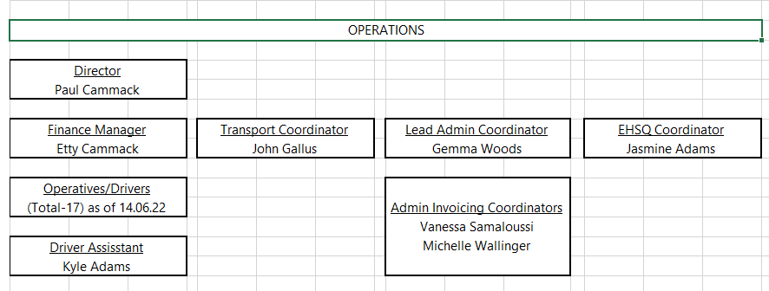

COMPANY DIRECTOR SIGN OFF DETAILS

As the Director of this company (CW), I (Paul Cammack), print, sign and date below to confirm the issue and authorisation for this Quality Policy Statement and all content to be communicated, issued and shared with relevant and necessary personnel and employees.

Name (printed): Paul Cammack. Position: Director. Dated: Tuesday 14th June 2022 (14.06.22).
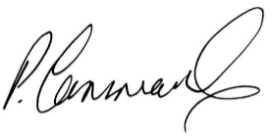
Signed:

